Business Continuity Support for COVID19
Client Information Sheet
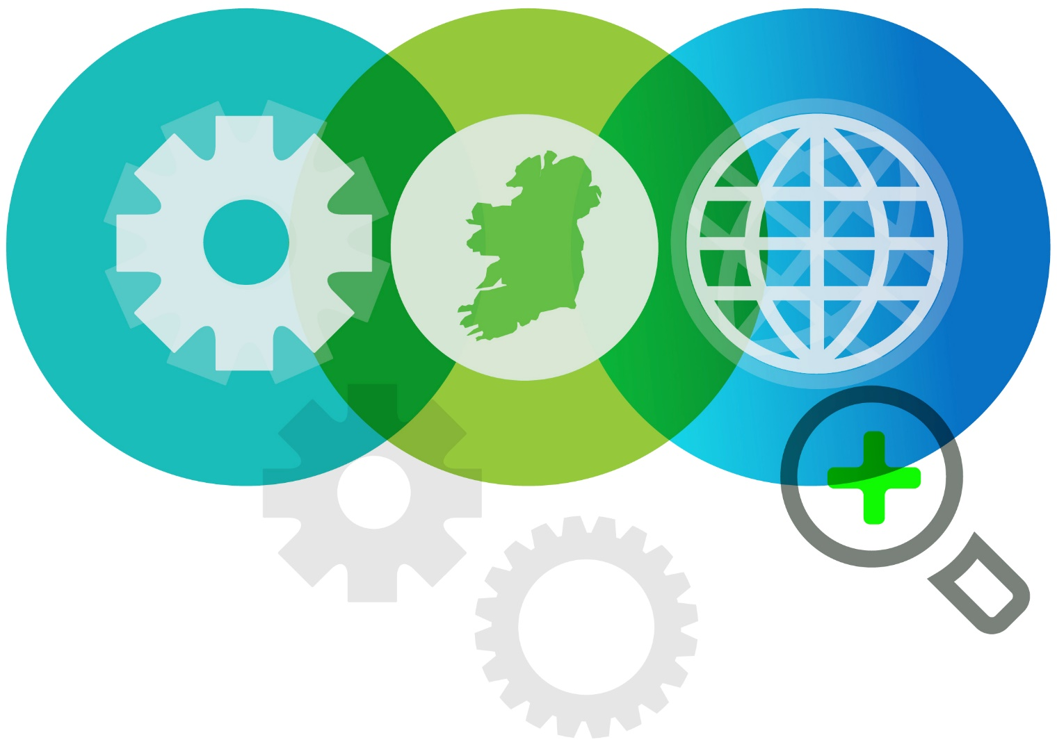
The Department of Enterprise Business and Innovation and its agencies, working with Ireland’s Service Providers have developed consultancy and training supports to help companies respond to the COVID 19 pandemic. These resources have been developed to support the implementation of the recently announced NSAI Guidelines. See Link
In addition to the normal supports that are provided to businesses through IDA Ireland, this new support for business continuity is also available. It focuses on two specific areas:
- Management team consultancy – this will be a one-to-one consultancy or a one-to-team consultancy with a competent provider to talk through issues related to the COVID19 or to support the development of the site’s Contingency planning or Business Continuity Planning

- Training for staff – Where clients need to continue to communicate and engage with their employees and provide guidance and training to them in any aspect associated with COVID19, this can also be achieved through on-line webinars and discussion guided by a trained facilitator.

Companies eligible to apply
This support is open to all IDA clients that need additional help and guidance to manage their operations during this pandemic. Predominantly, these will be companies in the IDA portfolio that do not have large international Business Continuity teams in place.
What do the Supports cover?
You can get help to manage your operations through the crisis period to create
- Defence – Defending against the spread of the virus
- Exposure – Management and reduction of detected on site cases
- Recovery – Recovery of processes and business functions after detection
Some of the areas that the providers and training can cover are:
- Crisis management-building rapid deployment capability
- Hygiene system and deployment of same
- Contact tracing and management
- Management of people through a crisis – communicating/Handling issues
- Coaching/mentor support for Leaders and Staff on mitigation and reduction actions
- Virtual Risk assessments on sites and reducing risks of contamination
- Preparing for external assessment eg by HSE/Department of Agriculture Food and Marine
- Rapid response to emergency situations eg rapidly disinfecting at pace
- Dealing with challenging logistics
- Carrying out risk assessments for business continuity
- Managing and supporting potentially compromised sub supply network
- Development of alternative uses for company site in the event of reduced demand for current products and services
- Redefining strategy resulting from reduced demand for current products and services
- Managing sub-contractors and suppliers
- Developing rapid understanding of market requirements post crisis and how to generate new business where existing business has been diminished by COVID19
- Sourcing alternative distribution channels and logistics
- Preparing for ramp up post crisis
This is not an exhaustive list and companies should contact their IDA Ireland Project Executive to find the right support depending on specific company needs.
Who delivers these supports?
We have sourced a range of consultants that have some experience and competence to help you in this time of crisis. Some have international experience of epidemics elsewhere and some have national experience of crisis in particular sectors here in Ireland.
How to Access the Business Continuity Support
Either through your IDA Ireland Project Executive or contact through the website www.idaireland.com
Funding
Funding is available for up to 33 days of consultancy or training to a maximum of €29,700 excluding VAT. This is 100% grant aided by IDA for IDA clients. IDA clients will need to pay the VAT to the service provider on submission of an invoice from them.
To Apply
  - Discuss support with your IDA Project Executive, who will guide you to the services provider database from which you will select a Provider. Link to Service Providers
  - Complete a short on-line application form hosted on Enterprise Ireland’s Website and approval will be provided through IDA Ireland for eligible companies Link to Application Form

